Bouncing heels Taken from “The dance between Joy and Pain” Dru Publications
Movement to remove fear
- Form fists with your hands and place them on the kidney area (the closed fingers face outwards).
- Holding your fists firmly in place, bounce up and down on your heels, keeping your toes on the ground.
- Do this at least 18 times.
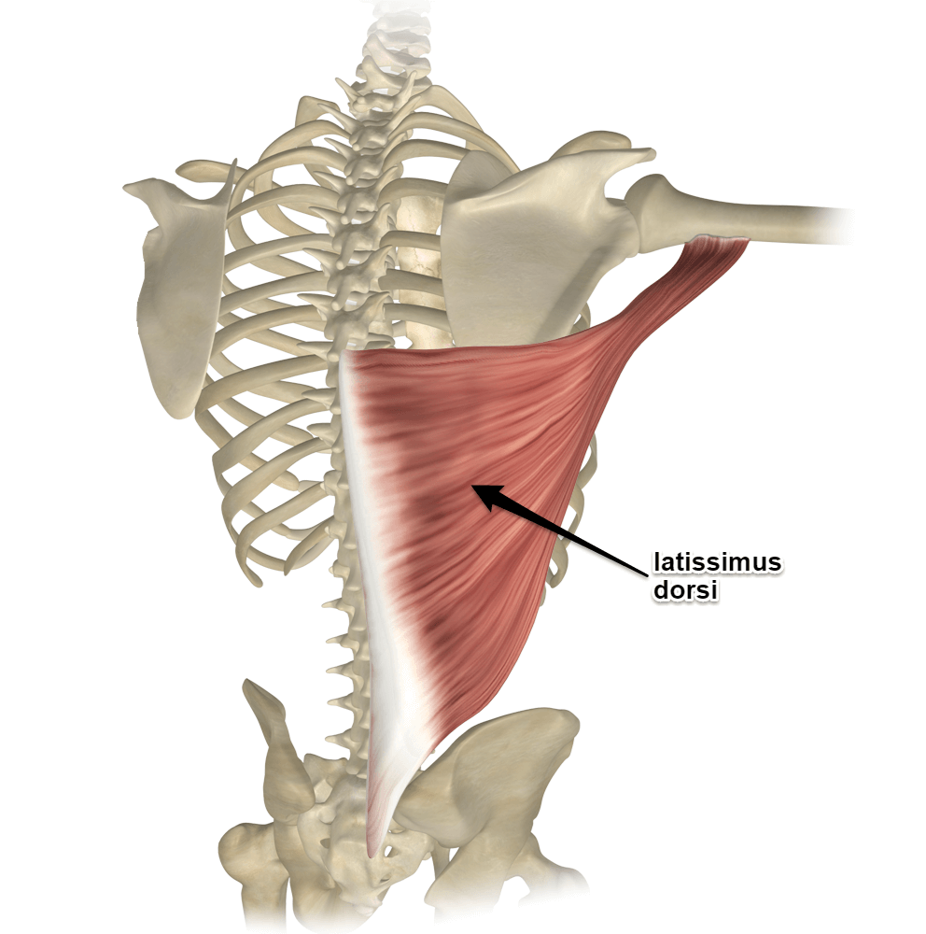
Affirm: I have the inner strength to face my life with courage.

Body Preps for Warrior sequence
Latissimus Dorsi – raise arms overhead, palms facing outwards, elbows bent, hold and repeat
You can prepare this muscle in three different ways. The best option is lying down and allowing gravity to stretch the muscle. But you can stand against a wall or with a partner standing back to back.
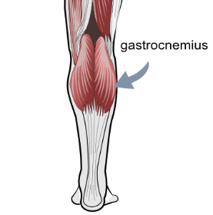
- Start with your back in contact with floor, wall or pressed against your partner’s back.
- Arms to your side, palms facing outwards. Knees up so that your feet are flat on the floor if you are lying down.
- Lift the arms upwards and over your head, keeping the arms slightly bent and allow gravity to stretch out your latissimus dorsi muscles (don’t force the movement because it is likely that your body will cheat by allowing your shoulder blades to wing out to the sides).
- Hold for 20-30 seconds, lower the arms and repeat two more times.
Gastrocnemius stretch – Standing runner, hold stretch into calf of back leg, repeat with the other leg
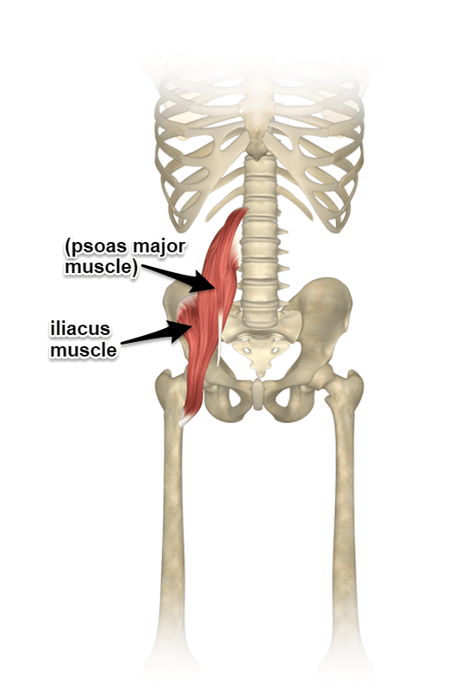
- Take one foot forward, bend the front knee and keep the back leg stretched out as in a standing version of runner.
- Hold for 20-30 seconds.
- Repeat with the other leg.

Iliopsoas stretch – standing or lying pull knee into belly. Alternatively kneel in runner. Hold and repeat on the other side. Note: this prep is also required for Warrior 2
Hip Adductor Stretch – seated Butterfly stretch. Note: this prep is for Warrior 2 only
Sit with knees outwards, soles of feet touching. Allow your knees to relax towards the floor.
Hamstrings stretch – lying on back, knees bent, soles of feet on the mat. Stretch your right leg into the air, hold calf or ankle, hold for 10 seconds. Repeat other side. Modifications: use a belt or band to reach your calf. For more intense stretch, straighten your other leg.
Standing alternative: Arms against wall, chair or shoulders of another person, walk back to make an L shape with the body, feel the stretch in the hamstrings at the back of the legs.
Gluteus Medius strengthening – lying on side, knees bend, raise top leg and hold for 10 seconds. Repeat 10 times on each side.
Standing alternative: Hold chair, raise right leg, knee bent, open sideways. Hold and repeat as per lying version.
Gluteus Maximus strengthening – lying on front, stretch right leg with toes curled under and hold for 10 seconds. Repeat 10 times on each side. For a stronger stretch bend knee and raise leg one centimetre off the ground. Hold for 10 seconds. Repeat 10 times on each side.
Standing alternative: take one leg slightly back, tuck toes under, constrict muscles up to the gluts (in the buttocks), hold and repeat as per lying version.
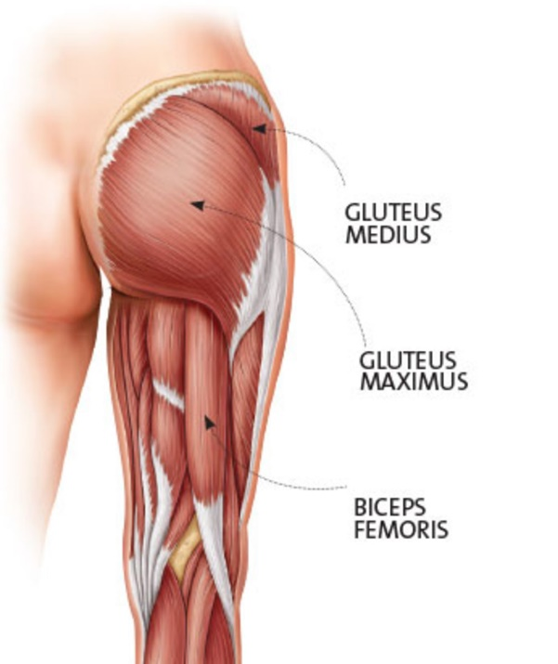
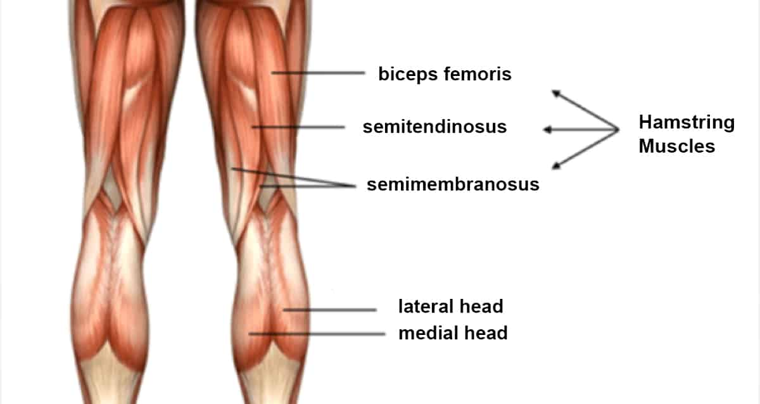

(Dru 1) Warrior II / Virabhadrasana 2
Theme: To become a warrior you need focus. Whenever you need to hone your focus, come into warrior pose. For example if you want to be an Eco Warrior, focus on what actions you can take that can have the biggest impact (e.g. become vegan) and then take immediate action. When the opportunity presents itself, the warrior always takes immediate action.
Benefits Strengthens legs, ankles, knees, hips and shoulders. Chest is expanded. Hamstrings are loosened. Balance and concentration are improved. Feel like a peaceful warrior.
Modifications: Taking the legs closer together will reduce the pressure in the lower back.
Steps
- From wide leg stance turn right foot 90 degrees, left foot 45 degrees, open arms out, bringing the right arm in front of you and the left arm behind.
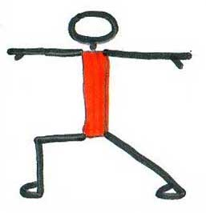
- Keep right knee bent and right thigh parallel to floor.
- Draw belly in.
- Shoulders directly over hips.
- Reach out through fingertips.
- The gaze is forward over right hand. Engage the triceps to support the arms, and the quadriceps to support the legs. Body is central, look over left hand to past, right hand to the future.
- Repeat on the left side.
(Dru 2) Warrior I / Virabhadrasana 1
Virabhadrasana 1 - known as Warrior 1 in most yoga traditions because the body forms a number 1. However, when put in a sequence this becomes the second warrior so Dru decided (in their wisdom) to be different and call it Warrior 2.
Theme: Inner and Outer Strength
Benefits Strengthens legs, ankles, knees, hips and shoulders. Chest is expanded. Hamstrings are loosened. Balance and concentration are improved. Feel like a peaceful warrior. Enhance the qualities of stability, determination, endurance, harmony, balance and poise. Activate manipura and swadhisthana chakras.
Modifications: Taking the legs closer together will reduce the pressure in the lower back.
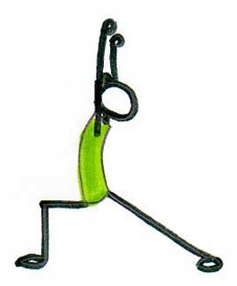
Steps
- Stand in Mountain Pose with arms extended overhead covering your ears.
- Hands can be in prayer position, interlocked or shoulder width apart.
- Spread legs wide and turn right foot at 90 degrees.
- To engage lower core abdominal muscles, pull navel up and back (will reduce pressure on lower back).
- It can be hard to get the back foot flat on the mat if the legs are too wide apart. It also makes it harder to face forward correctly with the chest. Therefore, adjust legs to a distance apart that allows both the back foot to be on the mat and the chest to be forward.

(Dru 3) Warrior III / Virabhadrasana 3
Theme: Inner and outer strength
Benefits Strengthens legs, ankles, knees, hips and shoulders. Chest is expanded. Hamstrings are loosened. Balance and concentration are improved. Feel like a peaceful warrior.
Modifications: Taking the legs closer together will reduce the pressure in the lower back.
Steps
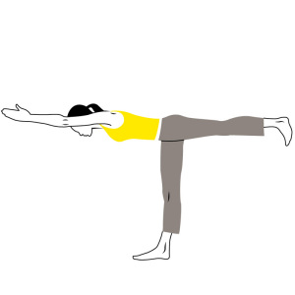
- From Warrior I bring hands onto hips.
- Bring weight forward into front foot as you gently kick up back leg.
- At the same time, bring torso forward until it is parallel to floor.
- Keep neck relaxed.
- Keep both hips pointing toward floor as you bring back leg in line with your body.
- Flex raised foot. Bring the arms back along your sides.
- Repeat on the other side.

